UNIVERSITY OF HARIPUR


Programming for AI Lab: 01

Submitted by: Hassan Nawaz
Roll No: F23- 1206
Program: Artificial Intelligence
Semester: 5th
Section: C
Instructor: Mam Zainab Noor
Submission Date: [13-10-2025]

1. Write a program to sum all the numbers between 1 to 100 using a while loop.
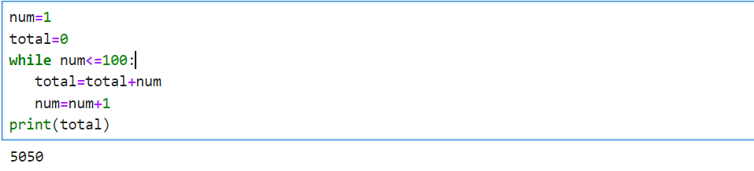
2. Write a program to print all the even numbers between 1 to 100 using a while loop.
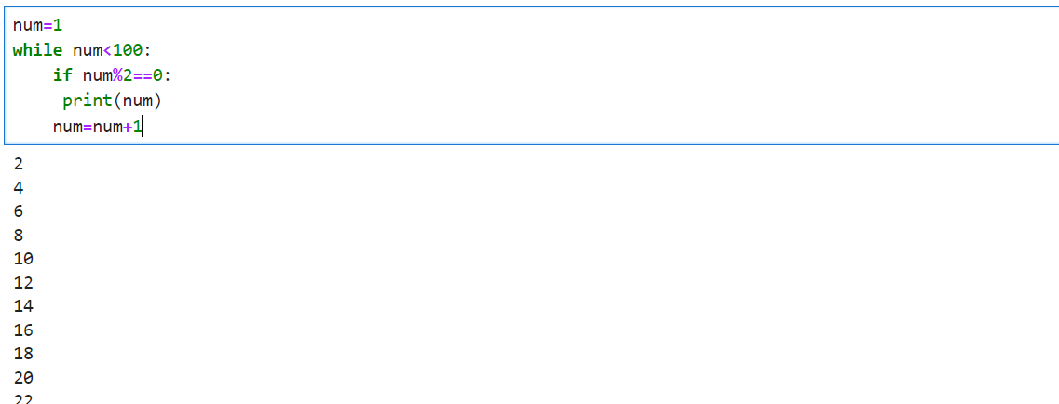

3. Write a program to check whether a number is prime or not.

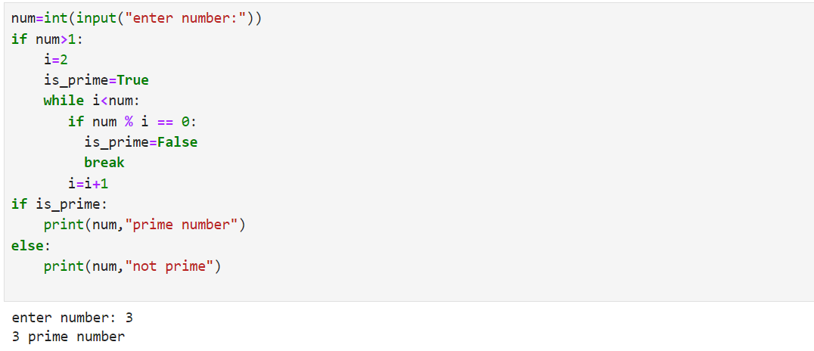
4. Write a program to prints all the characters except vowels (a, e, i, o, u) in a string given by the user.
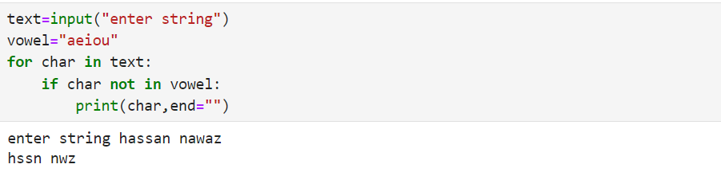

5. Write a program to find the sum of all the odd numbers between 1 to 100 using a while loop.
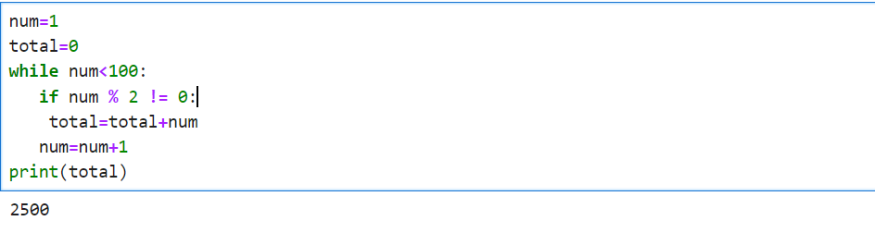

Thanks!

